Welcome to ConnectED
ConnectED is your gateway to your online curriculum resources. This document explains how to access ConnectED and what certain features do.

Logging In
To log in to your content, you will need a Username and Password. Your teacher will be able to provide these to you:
- Go to http://connected.mcgraw-hill.com for the ConnectED Login screen.
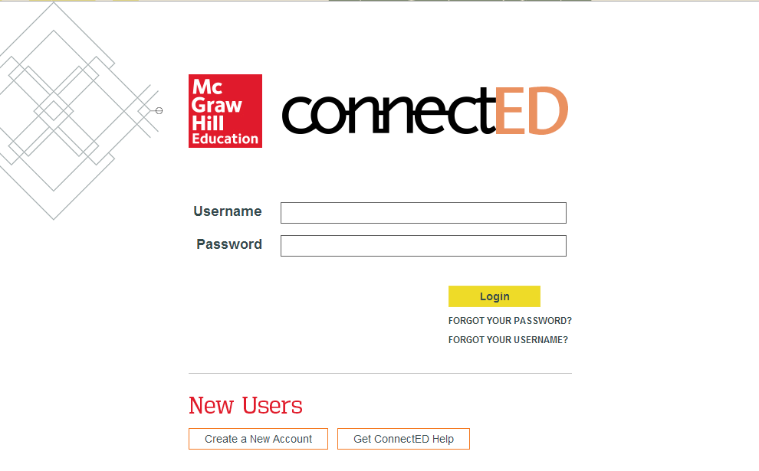

- Enter your Username and Password and click Login to display your Books and Content page.
To Do: Click this to see what the teacher has assigned.
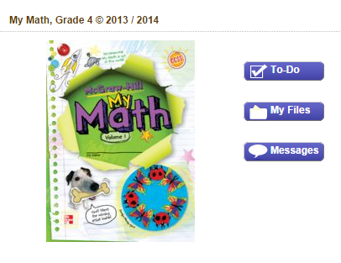
My Files: Click to see specific homework or worksheets.
Messages: Click for important notes or announcements from the teacher.
Click the book to open the Student Center.

- Your Student Center lets you open your class information, as well as other materials.
Help: This page has tutorials and user guides to help you understand how to use ConnectED.
Click ConnectED to
return to your Books and the Content page.

Messages: Important notes or announcements from the teacher.
My Discussions: Place for students to have online discussion to solve problems collaboratively.
Resources: The online tools that are connected to the lesson.
Find your place: Drop down menus guide you to the lesson pages.
Homework: Your latest assignment.

