Your child will be earning a reward for each color set of words they learn. At the end of the year students who have learned **all** their words **will join our ice cream party!!!!! Each month we will be learning 10 High Frequency Words. It is very important that your child keeps up with these words as it will impact his/her learning.**

**Sight words by Month**

| **August**  I  Can  The  we  see  a  like  to  and  go | **September**  you  do  my  are  with  he  is  little  she  me | **October**  for  have  of  they  said  want  here  this  help  too | **November**  after  again  an  any  ask  ask  by  could  every  fly | **December**  from  give  going  had  has  her  him  his  how  when |
| --- | --- | --- | --- | --- |
| **January**  just  know  let  live  may  of  old  once  open  over | **February**  put  round  some  stop  take  them  then  think  walk  were | **March**  **Review all** | **April**  **Review all** | **May**  **Review all** |

Dear Parents,

We are so excited for your children to begin exploring our reading program and watch them become readers. Our primary reading goal for the end of first grade is to have all students reading at **first graders or even beginning second grade material at a fluent pace**. Fluency is the ability to read like you are talking. Children must learn to read words quickly and correctly in order to understand what is read. When fluent readers read silently, they recognize words automatically. When fluent readers read aloud, they can read with expression. Readers who struggle in fluency read slowly, word by word, and focus on sounding out words instead of understanding the story.

In an effort to promote the students’ interest, we will be implementing a star words approach to teaching and learning this year’s high frequency words. High frequency words account for a large portion of material read. Some of these words can be read sound by sound, however, a large portion must be read through memory.

We will be working on 5-10 two words each week in class where students will be exposed to these words over and over. Homework will also be sent home for practice. Each student will receive an incentive for successfully reading each level of words and ultimately attend our rainbow words celebration at the end of the year.

**Ways to help your child at home include:** 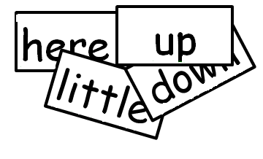

* Make flash cards using index cards
* Play games with the homemade flashcards
  + Place all cards face down on a flat surface
  + Have your child turn over a card and read the sight word.
  + Have your child turn over a second card and read the sight word. If the sight words match, your child keeps them. If they don't match, your child places them face down. Next it is your turn
* As you read a story together ask your child to read his/her high frequency words they recognize