Student Access to Google Classroom  Use this guide to show students how to access their online classroom.  1. Go to www.laveeneld.org and click on Google classroom.  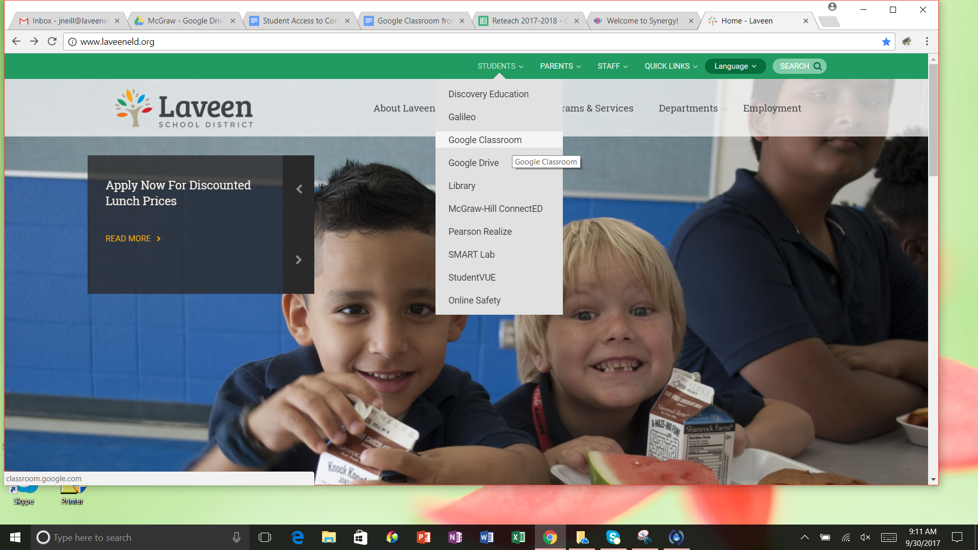  2. Log in using student’s school e-mail address followed by @stu.laveeneld.org as well as their given password which begins with St(case sensitive)  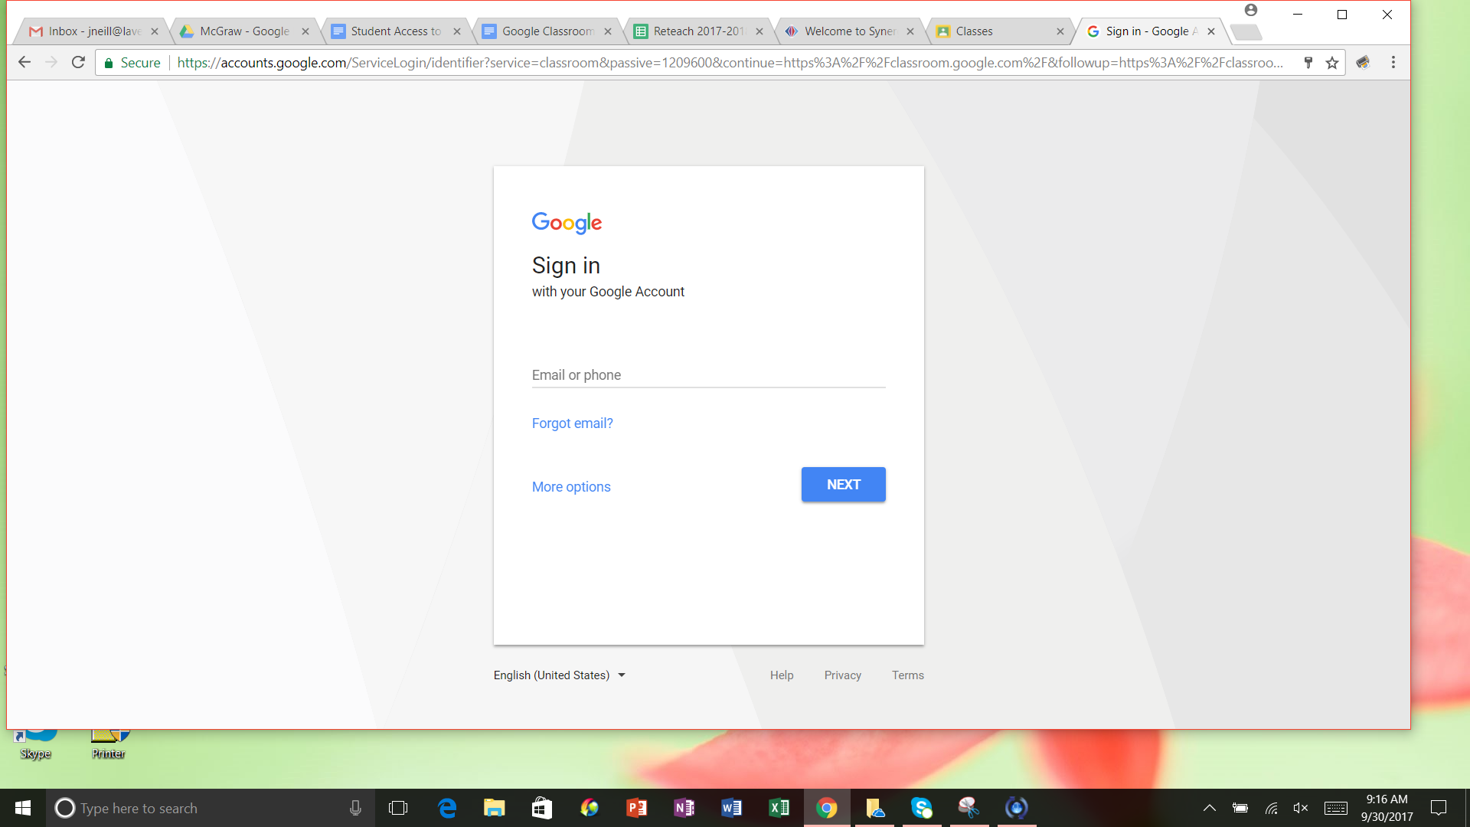 | 3. Once students have logged in they will see the classrooms they have access to.  4. Click on the appropriate class to access assignments.  