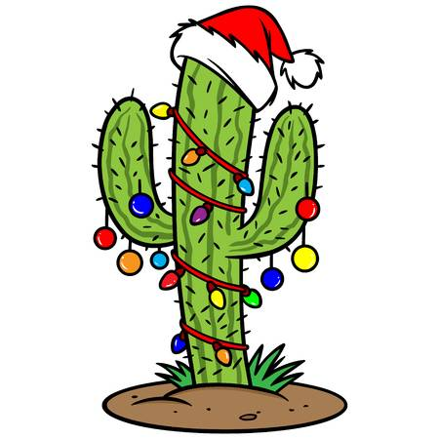
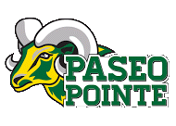
2nd Annual
Posadas at the Pointe
Wednesday, December 19th, 2018
5pm-7pm
Please join us for a fun night of family crafts, winter performances, and delicious food!

Please consider donating any of the following items by Wednesday, December 12th:

Consumable  - Small candies: jelly beans, mini candy canes, Mexican candy, etc  - Graham crackers  - White cake frosting  - Sprinkles  - Fruit Loops, or other colorful cereal  - Mini pretzels  - Mini marshmallows  - Hot chocolate: packets and bulk  Paper products  - Colored paper: red, green, and all colors  - Colored card-stock paper  - Constructional paper: light/dark brown and orange  - Ziploc bags: sandwich, snack, quart size, and with no zipper  - Paper plates: white and holiday-themed (any size)  - Small white cups | Art supplies  - Small pom pom fuzzies: red, yellow, and all colors  - Ribbon: poinsettia and Mexican sarape  - Brown pipe cleaners  - Stickers: circle, soft gem, emoji, star, rhinestone  - Foam self-adhesive stickers  - Googly eyes: all sizes  - Clear light bulbs  - Popsicle sticks: multi-colored  - Corn husks  Please send any donations to your child’s homeroom teacher

