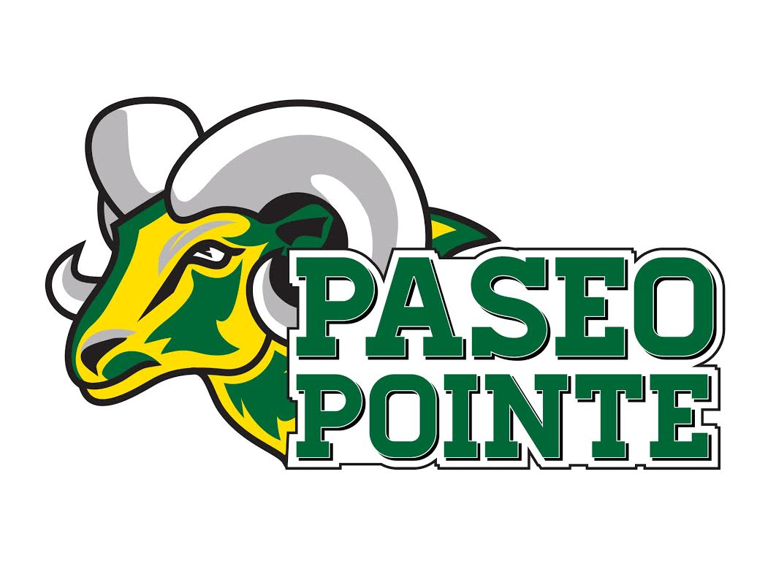

**RAM JACKETS!**

**ALL ORDERS ARE DUE BY SEPTEMBER 28TH**

Zipper Jacket Sweatshirt: $35.00 each

**\*CASH or MONEY ORDER ONLY*NO EXCHANGES WITH PERSONALIZED JACKETS\***

**Return form and payment to Mrs. Janca (library) or front office**

Name:

Phone: Email:

Student Name(s):

Teacher Name(s):

Youth Sizes (please select):

____ Small ___ Medium ____Large ____Extra Large

Adult Sizes (please select):

Small____Medium____Large____Extra Large

_____2XL (add $3) ______3XL (add $5)

Personalization on back: (limit is 14 characters)

For office use:

_____Paid _____Rec _____Delivered