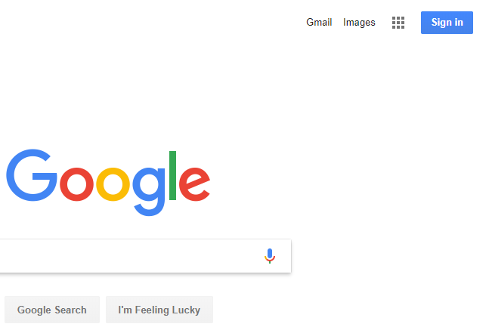

1. First go to google.com then click the blue sign in button in the top right hand corner.

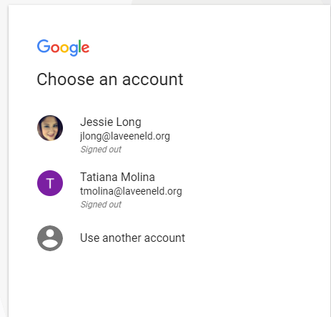

2. You will choose “use another account” then you will have your student type their school email address. This is the username on the sticker in their agenda followed by **@stu.laveeneld.org**

The password is the password on the sticker in their agenda.

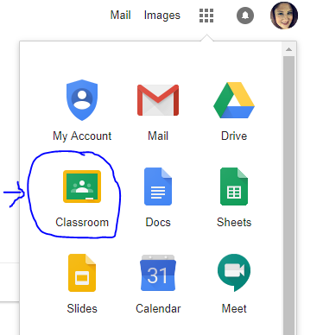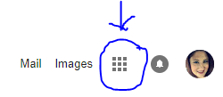

4. When you click the “waffle button” a drop down menu will appear. At this point the google classroom icon will appear. Click on the classroom icon.

3. Once you are signed in, click on the “waffle button” which is circled in the picture to the left.