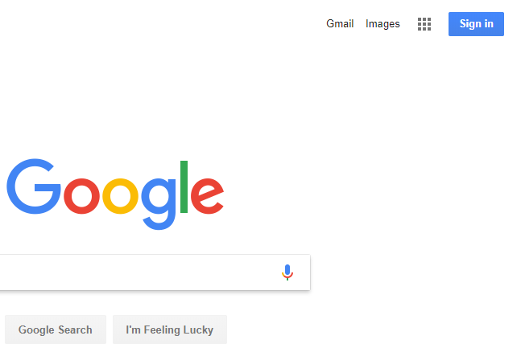

1. First go to google.com then click the blue sign in button in the top right hand corner OR SIGN OUT OF YOUR ACCOUNT

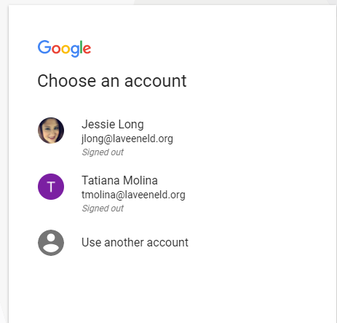

2. You will choose “use another account” then you will have your student type their school email address. This is the username on the sticker in their agenda followed by **@stu.laveeneld.org**

The password is the password on the sticker in their agenda.

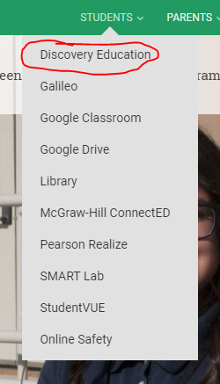

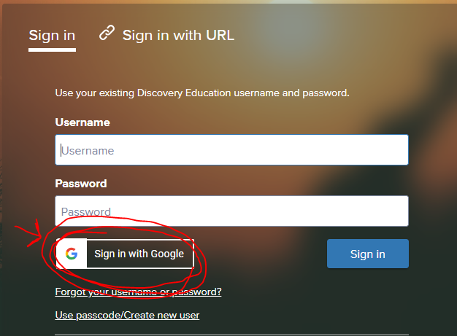

3. Go to laveeneld.org and click the student tab. Click on Discovery Education (circled in red to the left)

4. When you arrive at the Discovery Education log in page click **SIGN IN WITH GOOGLE**

**IF YOU ARE LOGGED INTO YOUR PARENT GMAIL ACCOUNT STUDENTS WILL NOT BE ABLE TO LOG IN TO ANY SCHOOL CURRICULUM